FOR IMMEDIATE RELEASE:
Contact: Caroline Vaught
carlymvaught@gmail.com
(812) 309-2311

NYT Bestselling Author Adam Silvera Seizes the
Day in New LGBT+ Contemporary

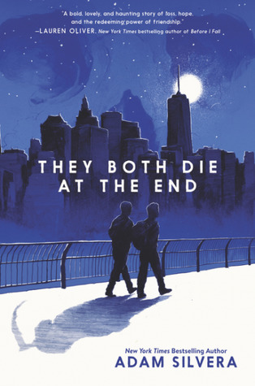
NEW YORK CITY, NY– Adam Silvera brings a beautiful blend of sci-fi and contemporary styles together to show the effects of death on young people and the importance of close relationships during hard times. Bringing together an artful mix of characters from different backgrounds and sexualities, Silvera shows that seizing the day and living your life like there’s no tomorrow can be the best kind of medicine.

When Death-Cast calls Mateo Torrez and Rufus Emeterio, they both know they have less than 24 hours to live. Suddenly, their lives are both changed – Rufus is on the run from his ex-girlfriend’s new boyfriend and Mateo is struggling with leaving his house. When an app called Last Friends brings them together, they embark on a journey of fulfillment in order to race the clock and live out the most amazing day while they still can.

In this book that Kirkus Reviews calls “Engrossing, contemplative, and as heart-wrenching as the title promises”, “carpe diem” takes on a whole new meaning. The relationship between Mateo and Rufus is contemplative and intense from start to finish and shows that sometimes the people you really need in life are those that can see you at your most vulnerable. Their journey of self-discovery gives courage to readers and pushes them to accept themselves for who they really are.

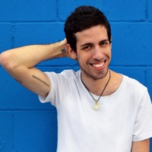
ADAM SILVERA: Adam Silvera is the New York Times bestselling author of More Happy Than Not and History Is All You Left Me, and the co-author of the epic love story What If It’s Us. He was named a Publishers Weekly Flying Start. Adam was born and raised in the Bronx. He was a bookseller before shifting to children’s publishing and has worked at a literary development company, a creative writing website for teens, and as a book reviewer of children’s and young adult novels. He is tall for no reason and lives in New York City. For more information, visit Adam Silvera’s website at www.adamsilvera.com.

“They Both Die at the End”
Adam Silvera | September 5th, 2017 | HarperTeen
Hardback ISBN: 0062457799 | Price: $17.99
Paperback ISBN: 0062457802 | Price: $10.99
Audio ISBN: 0062740695 | Price: $39.99
Young Adult, Contemporary, LGBT+

In An Interview Adam Can Speak About Topics Such As:

- Grief and overcoming loss
- LGBT+ community and growing up LGBT+
- Learning how to seize the day and accept who you are
- The importance of close relationships
- Children’s and Young Adult LGBT+ publishing

An Interview with
ADAM SILVERA

- How do you think, societally, we would handle having Death-Cast?
Honestly, it would probably take a while for people to actually accept it. I mean think about it. Suddenly, you know the day you’re going to die. That changes the whole foundation of society. People with anxiety would dread the first 1-3 hours of every day and there definitely would be people living crazy everyday with idea that there are no consequences. I would like to think it would calm down eventually, but it would be a good long while to convince people that it’s not a scam or witchcraft.

- What do you want readers to take away from your writing?
I think it’s really important for readers to see part of themselves in the characters. I want people to be able to relate to at least one character, because then it makes the experience of reading so much better. Having that relationship means that it has an impact on their life and maybe even change their perspective on life.

- How can They Both Die at the End inspire LGBT teens to come out?
I wanted to create characters that show readers that being LGBT isn’t something to be ashamed or nervous about. My hope is that they can read about Mateo and Rufus and see that it’s completely normal and that people like them exist out in the real world.

- Rufus and Mateo have almost opposite personalities. Is there a reason?
Realistically, you probably don’t hang out with people that are exactly the same as you are. By making Rufus and Mateo so different, I think it gives different perspectives on how they come to terms, ultimately, with dying. And they’re good for each other. Rufus pushes Mateo to go outside of his box a little and Mateo helps keep Rufus grounded.

- What would you do if Death-Cast called you one day?
I would definitely try to see all my friends and family. Even though it would be a shock, I think it’s important for them as well as me to get that kind of closure for something so impactful and final. I don’t know if I have the guts to go out and do a bunch of crazy things on my last day, but I would want it to be memorable so that the people I love can remember me for something.

